Thesis Title

Your Name
This dissertation is submitted for the degree of
Doctor of Philosophy
March 2022
School of Computing and Communications

Dedication goes here
(optional)

This page is for a personal statement or quote
(optional)

Declaration
This thesis has not been submitted in support of an application for another degree at this or any other university. It is the result of my own work and includes nothing that is the outcome of work done in collaboration except where specifically indicated. Many of the ideas in this thesis were the product of discussion with my supervisor xxx.
If others have worked on this research too, an explanation of their contribution goes here.
Excerpts of this thesis have been published in the following conference manuscripts and academic publications.
[Reference list here]

Abstract
The abstract outlines the purpose and main findings of the thesis research. Typical abstracts are up to 300 words long. Replace all the text below with your abstract.
The formatting for a thesis used to be specified by the Lancaster University Manual of Academic Regulations and Procedures (MARP), and the following guidelines are taken from the 2015 version. Nowadays the format is unspecified, other than that the text be in English, but the old guidelines are still useful.
Each thesis shall be preceded by an abstract not exceeding 300 words typed as specified below in a form suitable for use in major abstract indices.
The text of the thesis shall be word processed on good quality A4 paper (210 mm x 297 mm), leaving a left hand margin of 38 mm, and a margin of 25 mm on the other three sides. Diagrams and illustrations shall be reproduced or mounted on similar paper; any which cannot be folded on A4 size must be submitted in a suitable portfolio.
The author shall provide as an integral part of the thesis a comprehensive list of contents, including diagrams, illustrative matter and any appendices; bibliography comprehending all materials cited or referred to in the whole submission; and must indicate if any part of the thesis is bound separately.
As of 2022, a major concern is accessibility, and the fonts, internal spacing, and guidelines in this latest version of the template reflect that:
https://answers.lancaster.ac.uk/display/ISS/Accessibility+checklist+for+Microsoft+Word+documents
Note that each department may have rules to suit their particular preferences. Consult your supervisor.
And, of course, all the highlighted text (except in a table of contents or list of figures or tables) is to be replaced!

Acknowledgements
Thank you to a for b.
Thank you to x for y.
Thank you to Charles Weir of Lancaster University, UK and to Kayla Friedman and Malcolm Morgan of the University of Cambridge for producing the Microsoft Word thesis template used to produce this document.

Contents
1 Introduction 1
2 Style Examples 2
2.1 Heading 2 2
2.1.1 Heading 3 2
3 Figures, Tables, Etc. 4
3.1 Figures 4
3.2 Tables 5
3.3 Header and Footer 5
3.3.1 Editing Header and Footers 5
4 Bibliography 7

List of Tables
Table 1: Just a table 5

List of Figures
Figure 1: Penguins 4

List of Abbreviations and Acronyms
TLAB The list of abbreviations needs to be created by hand
IUS It uses style Index 1.
LOL Lots of Love
ROFL Rolls on floor laughing.

List of Appendices
Appendix A. Example Title 8

Introduction
To make the thesis text formatting consistent across the whole document, we use Word Styles. Each ‘style’ describes how some text displays – either a whole paragraph (Paragraph styles, such as Normal) or words within a paragraph (Text Styles, such as Strong).
To see the style for each paragraph, use View – Draft. To change the style for some text, select it, and click on the appropriate style on the Home tab, e.g.:
If you can’t see the style you want, click the Styles Pane button for the full list.
The following chapters describe the styles used in this template.

Style Examples
This section includes examples of all the styles used in the template. This text is in the Normal Style and should be used for body text. The Title above is in Heading 1, which is for chapter titles. It will automatically start a new page and includes some spacing before and after.
Below is a list of the heading style; the template supports up to 6 levels of headings. Only the top three levels appear in the table of contents. Headings appear in the table of contents up to Level 3.

Heading 2

Heading 3

Heading 4

Heading 5

Heading 6
Here are some other styles you may need:
- Bullet Style for bullet points
  - Bullet Level 2
This is a quote, using style Quote.
There are also ‘character styles’ to use for text within a paragraph. Emphasis suggests that a word or phrase is used in a particular way (like ‘within’ in the previous sentence); and Strong shows a phrase that you want to stand out from the page as a kind of summary. Those two are recognised by screen readers, so please use them in preference to just italic and bold.
Quote also works as a character style “for inline quotations”.
To add a footnote, use References—Insert Footnote. We don’t recommend using endnotes, as they get placed after all the appendices.

Changing Fonts
All of the text in this document is in one of two fonts: most text is in Cambria, and the headings are in Helvetica Neue. Both are acceptable both in terms of accessibility and in terms of reading comfort for those without accessibility issues.
If you wish, however, you can easily change the fonts for your thesis:
- To change the font for the main text, alter the font for style Normal;
- To change the font for headings, alter the font for style Heading 1.

Figures, Tables, Etc.
This section explores some other aspects.

Figures
Here’s a figure, with caption. It uses the style, Figure, and the caption goes below (style Caption). Use Control-click (Mac) / Right-click (Windows) – Edit Alt Text to set an alternative text for the visually impaired.
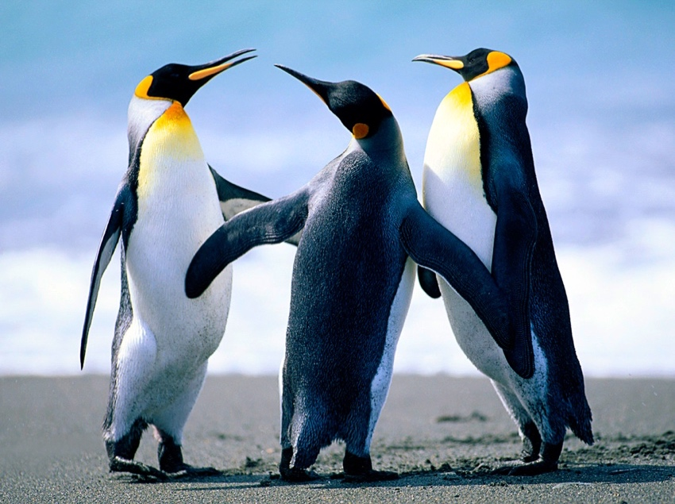
Figure 1: Penguins
Use Insert—Links—Cross Reference—Figure—Only Label and Number and select the right figure to create a reference to it: Figure 1.

Tables
Here’s a table, with caption. Table captions go above the table. Use Insert—Links—Cross Reference—Table—Only Label and Number and select the right table to create a reference to it: Table 1.
Use Right/Control click—Table Properties—Alt Text tab to set a title and alternative text for those who have difficulty with reading tables.
Table 1: Just a table
A | B
C | D
Word supports lovely preset table formats, but you don’t always want them. To remove them, and just have a normal table with text in it, there’s a very well-concealed option that took me five years to find: select the table, click the Table Design tab, hover over the table format images, click on the little ‘v’ tab that appears at the bottom, go down to the bottom of the page of formats, click ‘Clear’.

Header and Footer
The template is automatically set up with Headers and Footers.
As default
- Cover pages have no headers or footers
- Front matter have no headers, and footers contain only page numbers in Roman numerals
- Main pages have headers with your thesis title, name, and date. Footers contain the chapter title and the page number in Arabic numerals.
The title of the thesis and your name are set on the cover page. The date updates automatically.
The template supports different headers and footer for odd and even pages. This allows the page numbers to switch sides as they do in a book.

Editing Header and Footers
Other places have full guides to working with headers and footers, so this is just a few notes on headers and footers in the template.
The template breaks the links between headers and footer on previous pages at:
- The cover page
- The front matter
- The main section of the document
- Between odd and even pages
If you tamper with headers and footers, you may find odd things happen in other parts of the document. Nevertheless, if you do want to make a change this checklist should help.
- Do you want you change to happen on both odd and even pages? If so, you will need to make all the changes twice.
- Do you want the change to cross the boundaries between sections? If so you will have to make the changes on both sides. I recommend not relinking sections unless your are a Word Expert.
- Will any of the changes you make remove or alter sections, chapter headings, and the cover page? If so, you may have to redo the headings and footers manually.

Bibliography
The bibliography table uses the style Bibliography. Note that some reference managers (Mendeley, for example) don’t set a style for their references, and after updating the references you may need to select the bibliography table and reset the styling using Format – Style – Bibliography.
[1] John Abdul Kargbo (2010) Undergraduate Students' Problems with Citing References, The Reference Librarian, 51:3, 222-236, DOI: 10.1080/02763871003769673
.

- Example Title

As a default, appendixes do not appear in the table of contents but instead have their own table of appendices.
To achieve this appendices have their own heading style, Appendix Heading 1, which is visually similar to the main headings but are functionally different.
Appendix Headings automatically start on a new page.

Extra appendix page to check that the heading is OK.
Lorem ipsum dolor sit amet, consectetur adipiscing elit, sed do eiusmod tempor incididunt ut labore et dolore magna aliqua. Ut enim ad minim veniam, quis nostrud exercitation ullamco laboris nisi ut aliquip ex ea commodo consequat. Duis aute irure dolor in reprehenderit in voluptate velit esse cillum dolore eu fugiat nulla pariatur. Excepteur sint occaecat cupidatat non proident, sunt in culpa qui officia deserunt mollit anim id est laborum.

https://html.spec.whatwg.org/multipage/text-level-semantics.html#the-em-element
This is a footnote
https://accessibility.psu.edu/legibility/fontface/

